Course Era Capstone

IBM Professional DATA SCIENCE Capstone

Jan 2020

*“Want to open a New Multiplex in Tampa? Here's what data says”*

Submitted by

Sai Suraj Argula

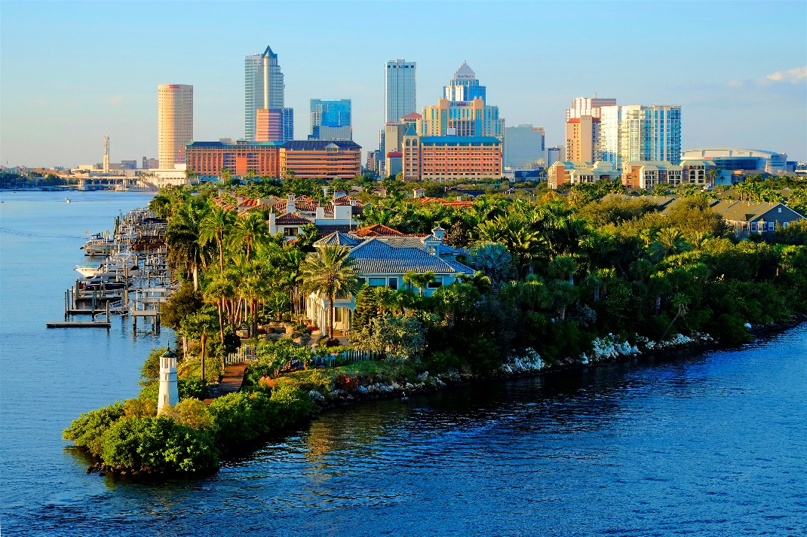

**Introduction**

In the era of fast-moving world, Movie theatres play an important role of providing relaxation to General people. Though online streaming services like Netflix, Hotstar and Amazon prime taken over a part of finances and profits in the entertainment Industry, movie theatres still be able to bring crowds who prefer experience compared to convenience. Movie theatres become one stop destination for entertainment, food and beverages. Increasing number of movies, along with increase in millennials who prefer theatres, demand for new movie theatres in the neighborhood which is accessible increased.

**Business Problem**

Foreseeing increased demand of New Movie theatres, company XYZ Entertainment wants to expand by investing in construction of new theatres. As a pilot project XYZ Entertainment choose City of Tampa as a start point to identify possible places to construct theatre. XYZ Entertainment needs the theatres to be constructed in the neighborhoods which are away from existing theatres, so that they can avoid possible competition.

**Approach**

As company wants to identify the neighborhoods which doesn’t have and have existing theatres. Analytical team decided to use K means clustering to cluster the neighborhoods into three groups of having more, moderate and less concentrations.

**Data Requirement**

For the data analysis team has come to brainstom the data needed for project, identify neighborhoods of Tampa along with its location data (longitude and latitude). Data of the existing theatres with its location.

**Data Collection**

Data required regarding the neighborhoods has been collected from Wikipedia website of all the residential neighborhoods in the city of Tampa (<https://en.wikipedia.org/wiki/Neighborhoods_in_Tampa,_Florida>). Python libraries packages like requests and Beautiful Soup helped in web scraping the page. For locating the neighborhoods location data i.e., latitude and longitude python library of Geocoder is used. All the information is tabled into a pandas DataFrame with neighborhood, latitude and longitude.

Foursquare City square API(<https://foursquare.com/city-guide>) has been used to locate the nearby venues (movie theatres in particular) in and around each of the neighborhoods.

This project has been built from scrap, using many data science skills like web scraping, data cleaning, machine learning, data visualizations.

**Audience**

This project will be useful for XYZ company to identify possible areas of construction. We can use the same methodology used in this project to do other similar projects of identifying venues as well.

**Methodology**

Build a dataframe of neighborhoods in Tampa, Florida by web scraping the data from Wikipedia page of Tampa Neighborhoods using Beautiful Soup library. Obtaining geographical coordinates of each neighborhood using Geopy library. Build a new dataframe of neighborhoods and its location (longitudes and latitudes).

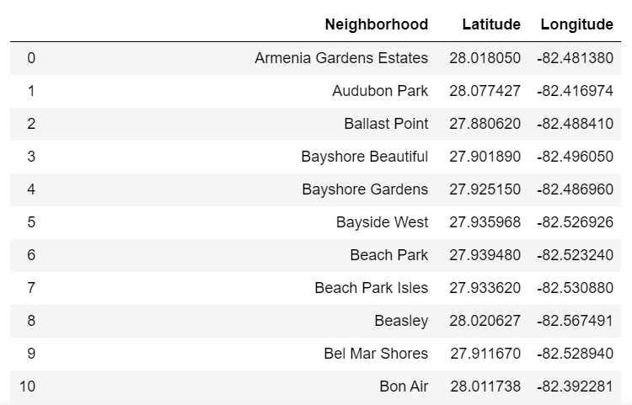

Visualize the neighborhoods in Tampa map using Folium.

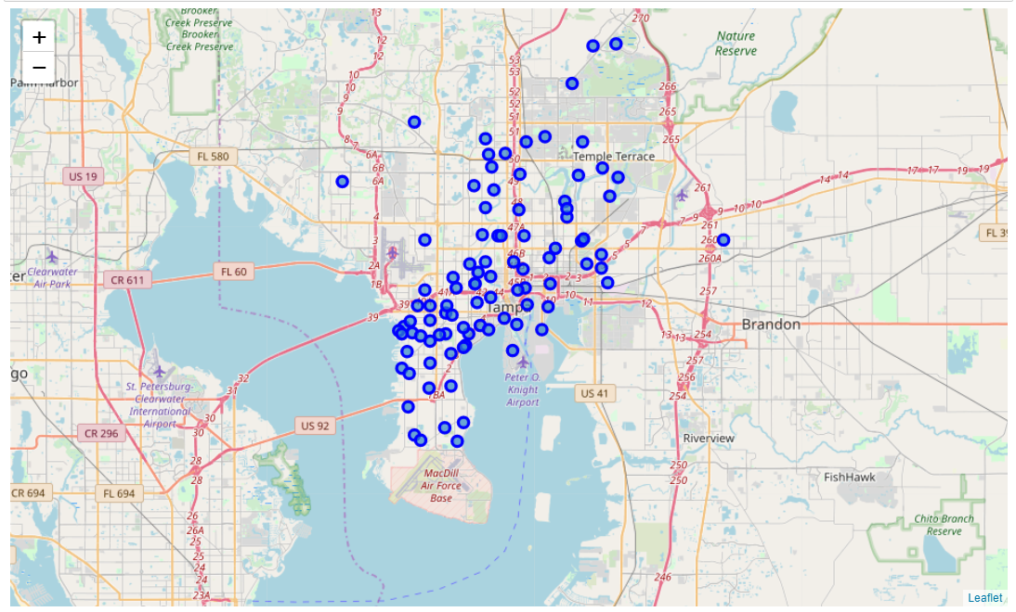

Get current location of venues in the vicinity of each neighborhood and filter movie theatres venues in and around each neighborhood using data from Foursquare API. Explore and Analyze the neighborhoods from the data obtained and cluster the theaters and neigbourhoods with K- means clustering, use folium to visualize neighborhoods and clusters. Select the best cluster for opening multiplex.

**Results**

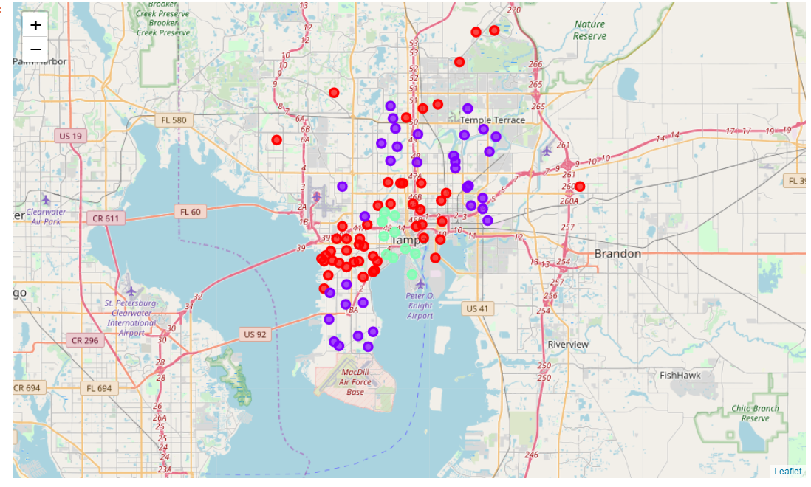

From the above map we can see movie theatres are more concentrated in the areas of cluster cyient and moderately concentrated in cluster red i.e these neighborhoods have theaters in the vicinity and the neighborhoods in the violet color have less concentration of theaters.

**Discussion and limitation**

If we construct theaters in these regions there are more chance of having less competition and more occupancy and in turn more profits for the company. Also, the results are independent of population in neighborhoods, their inclination towards watching movies in theaters and property costs.

**Conclusion**

Data available about neighborhoods and Movie theaters helped Company XYZ Entertainment to identify one of the neighborhoods with the low concentration of theaters to begin their operations.